Grade 9
2025-2026 REGISTRATION FORM

5757 Rochdale Boulevard, Regina SK S4X 3P5
Phone: (306) 791-7260
E-mail: RiffelHighSchool@rcsd.ca
Website: www.rcsd.ca/riffel/

We are a Catholic High School providing high quality instruction,
grounded in Catholic values.

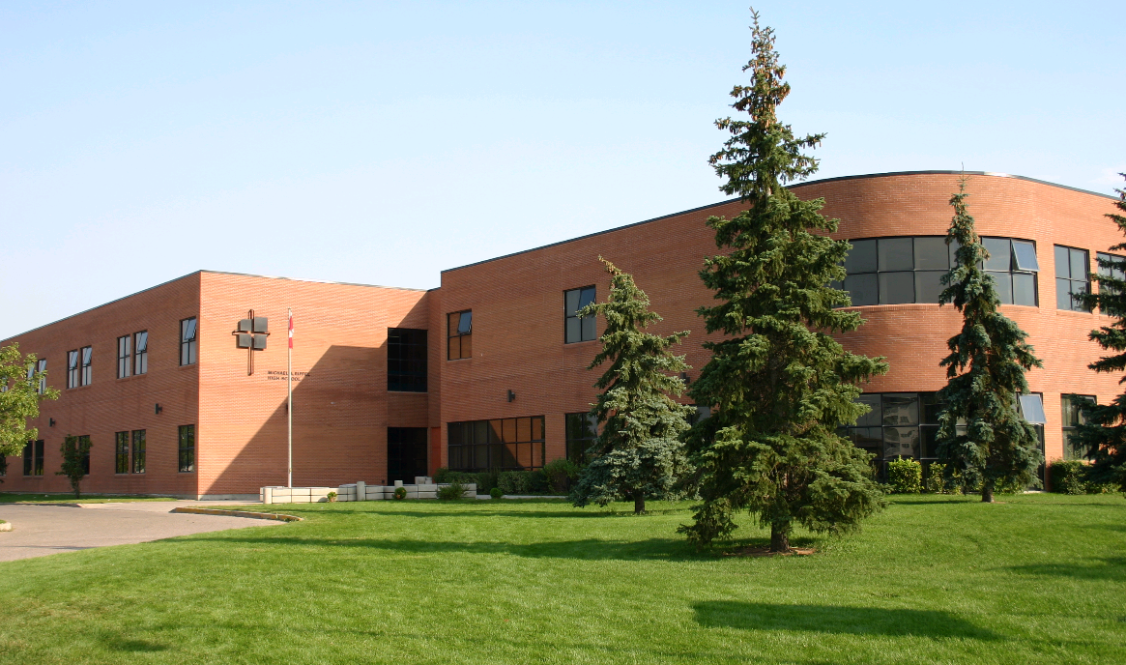

Principal: Mr. Tyler Wright
Vice-Principal: Ms. Amy Sanville
MISSION
The Regina Catholic School Division is dedicated to working with the community and local church to provide a quality Catholic education that fosters academic excellence and the development of
Informed, responsible citizens.

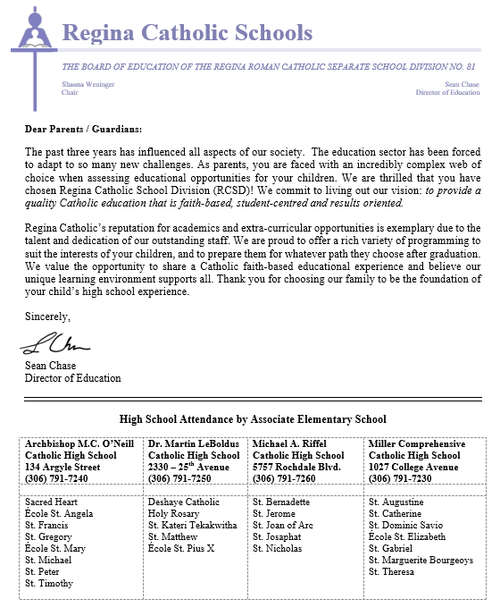

THE GRADE 9 PROGRAM

Grade 9 students register for a full year of classes. These classes will be divided and timetabled into two semesters.

Compulsory Subjects
English Language Arts A9 & B9
Mathematics 9 (both semesters)
Social Studies 9
Science 9
Arts Education 9
Catholic Studies 9
Phys. Ed./Health 9

Elective Subjects – Indicate top 3 choices with a 1,2 and 3. Students will be scheduled for 1of the top 3 choices:
- PAA Survey 9 Career Studies/Computer Technology
- PAA Survey 9 Career Studies/Foods
- PAA Survey 9 Career Studies/Industrial Arts
- PAA Survey 9 Career Studies/Interior Design

(R) Restricted Entry
ALL STUDENTS

All students may enrol in choral and/or band and/or vocal jazz in addition to the other subjects they are taking.

- Vocal Jazz 9 (both semesters)(twice/week)  Band (both Semesters (twice/week)
- Choral 9 (both semesters)(twice/week) Band experience ____ years
Instrument _____________________

Physical Education Uniform
Uniform - Shorts: please circle Uniform – Tops: Please circle

Small Large Small Large
Meduium Extra Large Medium Extra Large

- these are adult sizes
Additional Information  Has your son/daughter required adaptations because of learning challenges in the past? Yes No | EAL (English as an Additional Language)  Has your son/daughter had the support of an English as an Additional Language teacher in the past?  Yes No

TO BE COMPLETED BY PARENT/GUARDIAN

- I agree to the course selections made by this student and to the release of all educational records and applicable information from previous schools.

_______________________________ ________________
Student’s Name Parent/Guardian’s Signature Date

Michael A. Riffel Catholic High School
2025-2026 School Registration Form

Legal Last Name: (as it appears on birth certificate) Gender: M F ☐U
Legal First Name: Name Used: ________________ Middle Name:
Apartment #: _______ House #: ___________ Street / Box #:
Regina, SK or _______________________________________ Postal Code: Home Phone #: _____________
Birth Date: ________ ________ ________ Grade Level Student’s Cell Phone
MM DD YYYY

Previous School: (include address if out of Sask)

Indigenous Self Declaration (Voluntary): An Indigenous person in Canada is a First Nations, a Metis or an Inuit person. First Nations “Registered Status” refers to an individual recognized by the Canadian federal government as being registered under the Indian Act. First Nations “Non-Status” refers to a First Nations person who is not registered under the Indian Act.
Based on this definition, do you self-declare as an Indigenous person?
YES NO

If Yes please indicate:
First Nations (Registered/Treaty/Status First Nations (Non-status) Métis Inuit/Inuk
Band Affiliation:

Citizenship 1: Citizenship 2: 1st Language:
2nd Language: Country Birth: Country Origin:
Resident Type: Refugee Permanent Resident Temporary Resident Student/Visitor Visa Canadian Citizen (NA)
EAL Students – CFR Level Date of Arrival in Canada

Property Tax Support: Home Owner ( Separate Public Split) OR Renter

Father’s Religion: Mother’s Religion:
Student's Religion: Parish:

Contact Information:
1. Lives with student Relationship: Father Mother Stepfather Stepmother Grandparent Guardian
Dr./Mr./Mrs./Miss/Ms. First Name: _______________________ Last Name:
Work Phone: __________________ Cell Phone: __________________ Home Phone: (If different than student)
Address: (If different than student)____________________________________________________________________ Mail To
E-mail:

2. Lives with student Relationship: Father Mother Stepfather Stepmother Grandparent Guardian
Dr./Mr./Mrs./Miss/Ms. First Name: _______________________ Last Name:
Work Phone: __________________ Cell Phone: __________________ Home Phone: (If different than student)
Address: (If different than student)____________________________________________________________________ Mail To
E-mail:

3. Emergency Contact ________________________________________ Home Phone ____________ Cell Phone
Emergency Address ____________________________________________________________ Business Phone

Siblings: 1) Name: At this school
2) Name: At this school

