MICHAEL A. RIFFEL

CATHOLIC

HIGH SCHOOL

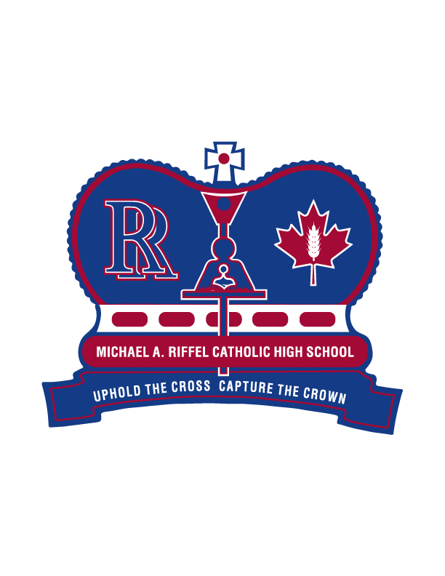

2025

GENERAL GRADUATION

MASS & EXERCISES INFORMATION

MICHAEL A. RIFFEL CATHOLIC HIGH SCHOOL POLICY

1. In order to participate in the graduation mass and exercises, a student attending a Regina Catholic High School must be deemed graduation eligible. Graduation eligibility is defined as the potential to earn a minimum of 24 credit units, including Catholic Studies 30 and the compulsory requirements outlined by the Ministry of Education, by June 30 of that academic school year. A determination of a student’s eligibility will be made after June 2rd, 2025 and will be dependent upon a student having a passing grade in all required courses. Summer school will no longer be considered when determining graduation eligibility.
2. A potential graduation eligibility list will be shared throughout the year. It is the responsibility of students to ensure that their name is on the list, and to verify the spelling.
3. In keeping with school division policy, we at Michael A. Riffel Catholic High School believe that a student's academic achievement should be recognized in a Catholic atmosphere. This belief will be manifested at the GRADUATION MASS AND EXERCISES.
4. We strive to keep costs reasonable and affordable for all graduands.

Regina Catholic Schools Board Sanctioned Graduation Mass and Exercises Provisions

Michael A. Riffel Catholic High School is pleased to be formally involved with the Graduation Mass and Exercises. These two events are school Board sanctioned activities that all Regina Catholic High Schools are required to organize, plan and supervise on behalf of graduating students and families. As such, it is very important that all students and families observe the regulations concerning appropriate dress, drugs/alcohol and respectful behavior as outlined in RCS School Board policies and our School Student Handbook.

A Grade 12 Prom has traditionally been organized by a parent committee near the end of May. In regard to this event and any other events/activities organized around and outside of the graduation mass and exercises, please keep in mind that they are not School Board sanctioned graduation events and therefore are not a part of Regina Catholic Schools’ supervision and liability.

TIMELINE

September | Ongoing until February 1st, 2025 (deadline) – Payment of Graduation Fees ($100)
November | Wednesday, November 14th, 2024 – Graduation Information Night for Students, Parents & Guardians @ 6:00 pm in Riffel Gymnasium
February | Register online for Grad Photos – link to be provided Feb 2025
March | Cap and Gown Pictures - March 24, 25, 26, 27th and 28th, 2025 (Commons area at Riffel from 9:00 am to 3:30 pm)
March | Retake Date – At the studio. Call (306) 949-8448 for a retake appointment.
March | Updated Graduation Eligibility list posted.
May | Voting on Grad speeches: May 2-16, 2025  Notify Ms. Tara Fisher (t.fisher@rcsd.ca), Graduation Chair, of wheelchair seating needs by Friday, May 23, 2025
June | Monday, June 2nd, 2025 - Final determination of graduation eligibility.
June | Tuesday, June 24th, 2025 - Rehearsal Assembly – All graduands MUST attend. This rehearsal is essential, and its importance cannot be overemphasized. We will assume that students who do not attend the rehearsal will not be attending the graduation ceremonies.
June | Tuesday, June 24th, 2025 – Graduation Gown, Cap and V-stole pick-up at Riffel in the Commons Area immediately following the Rehearsal.
June | Wednesday, June 25th, 2025 – Graduation Mass at Resurrection Parish (3155 Windsor Park Road) at 12:30 pm
June | Friday, June 27th, 2025 – Graduation Exercises at Conexus Arts Centre at 9:00 pm. Doors open at 8:30 pm – graduands must arrive at 8:30 and proceed backstage immediately (do not bring phone or other items backstage).  Please check the graduation page on our school website and the Edsby Group “Graduation/Post-Secondary News - 2025” regularly to stay up to date.

FEES

A Graduation fee of $100.00 includes:
Cap, v-stole and gown rental, church and Conexus Arts Centre rental, printing of programs, printing of invitations, printing of certificates, art legacy and miscellaneous items/guests/liturgy.

Fees for graduation will be collected until February 1st, 2025. All grad fees are to be paid via SchoolCash online program. The link is located at the bottom of the school website.

PHOTOGRAPHY

Cap and Gown Photographs at School

Graduation pictures will be taken at the school on March 24th, 25th, 26th, 27th and 28th, 2025. You must have your picture taken for the yearbook and composite even if you are not purchasing a package.

Portraits

Lifetouch will take the formal photographs of the graduands in cap and gown. The photos will be available by appointment on each day from 9:00 am to 3:00 pm – Riffel Commons Area. Each appointment is 15 minutes in length. You must pre-register. Sign up will be done on-line, and an email will be sent to all graduands with directions as to how to register. The Riffel website will have this information on it as well. The website to register is http://www.lifetouch.ca/Regina. The cost to receive seven cap and gown proofs and three contemporary proofs (4" x 5") plus an 11" x 14" class composite is $30.00. If you do not wish to receive a proof package, you must still have a photo taken free of charge, and it will appear in the yearbook and the graduation composite. If you do not purchase a proof package, you will not receive the complementary composite.

Graduation retake pictures will be taken at the Lifetouch Studio.
You must make an appointment by signing up online, or calling (306) 949-8448.

WEDNESDAY, JUNE 25TH, 2025 – GRADUATION MASS

Resurrection Parish at 12:30 pm

- Graduands are encouraged to “Dress for Jesus” and will wear their graduation gowns (no v-stole/cap)
- Graduands are welcome to sit with their loved ones (family and friends) during mass.
- We ask that those in attendance refrain from wearing hats during the graduation mass and to not bring in any food or drink into the church.
- For the benefit and enjoyment of all those in attendance for our graduation mass, we are requesting that individuals refrain from leaving the building during any portion of the mass. This ensures that noise and distractions are at a minimum. The entire program runs approximately 1.5 hours.

FRIDAY, JUNE 27TH, 2025– GRADUATION EXERCISES

Conexus Arts Centre at 9:00 AM

- Doors to the Conexus Arts Centre will open at 8:30 am and exercises will begin at 9:00 am. Seats are available on a first-come basis.
- Graduands are to arrive at 8:30 am and proceed back-stage immediately – they should not bring any phones or other items with them backstage. They will be directed to their name-tagged seats on the risers on the stage, where they will be seated for the entire program.
- Please note that the Conexus Arts Centre, does not allow food or drink in the auditorium.
- Conexus Arts Centre must enforce the provincial and city smoking bylaws which state that smoking/vaping is not allowed inside a public building at any time, and that such activities must be done outdoors a minimum of three metres (15 feet) from any building entrance.
- For the benefit and enjoyment of all those in attendance for our graduation exercises, we are requesting that individuals refrain from leaving the building during any portion of the graduation exercises. This ensures that noise and distractions are at a minimum. The entire program runs approximately 1.5 hours and this may prove lengthy for small children.

ACADEMIC DRESS REQUIREMENTS

(CAP & GOWN)

The academic dress worn by the Graduand consists of a blue gown, cap and a red v-stole. The cost is included in the graduation fee, and grads can keep their gown, cap, and v-stole.

Gowns, caps and v-stoles MUST be picked up at the school on Tuesday, June 24, 2025 in the Commons Area immediately following Graduation Rehearsal.

Dress clothing is required under the gowns and nice shoes should be worn. Please NO shorts, flip-flops, or beach type shoes of any kind may be worn.

VALEDICTORIAN & SALUTATORIAN

The role of the VALEDICTORIAN is to serve as the representative voice of the entire graduating class. This position should be looked upon as an honour. The SALUTATORIAN, also an honoured position, has the responsibility of welcoming everyone to the graduation.

Procedure for Selecting the Valedictorian and Salutatorian

The top four eligible graduands based upon Semester One averages are eligible and have been nominated for Valedictorian and Salutatorian. The nominee receiving the highest number of votes will be the Valedictorian and the nominee receiving the second highest number of votes will be the Salutatorian. These speeches will be determined based on grad eligibility.

The Valedictorian and Salutatorian must have their speeches approved by the Graduation Chair and School Administration. School Administration reserves the right to remove any student from these roles if they do not adhere to the recommendations regarding speeches.

Art Legacy

Graduating students contribute towards the purchase of a piece of art, which is donated to the school as their legacy. The works of art from previous years are displayed at the school with accompanying plaques indicating title, artist, year and contributor.

